Chatbot Based Music Recommendation System

In this project we developed a Chatbot based music recommendation system where user can interact with Chatbot and while interaction Chatbot will identify user emotions from his words and based on words description Chatbot will suggest some songs to users and user can play them.

In this project admin can login to system using username and password as ‘admin’ and ‘admin’. After login admin will upload songs and its descriptions. Admin can view list of users

New User can sign up with the application and then can login and interact with Chatbot with basic questions like asking Chatbot describe himself, working how long hours, Type of music and greeting words can be ask and asked for songs on sad, joy, happy, romance and all those terms admin will use while uploading songs.

To run project install Python 3.7 and then install all MYSQL database and then copy content from DB.txt and then paste in MYSQL to create database.

To run project double click on ‘run.bat’ file to start python server and then will get below page

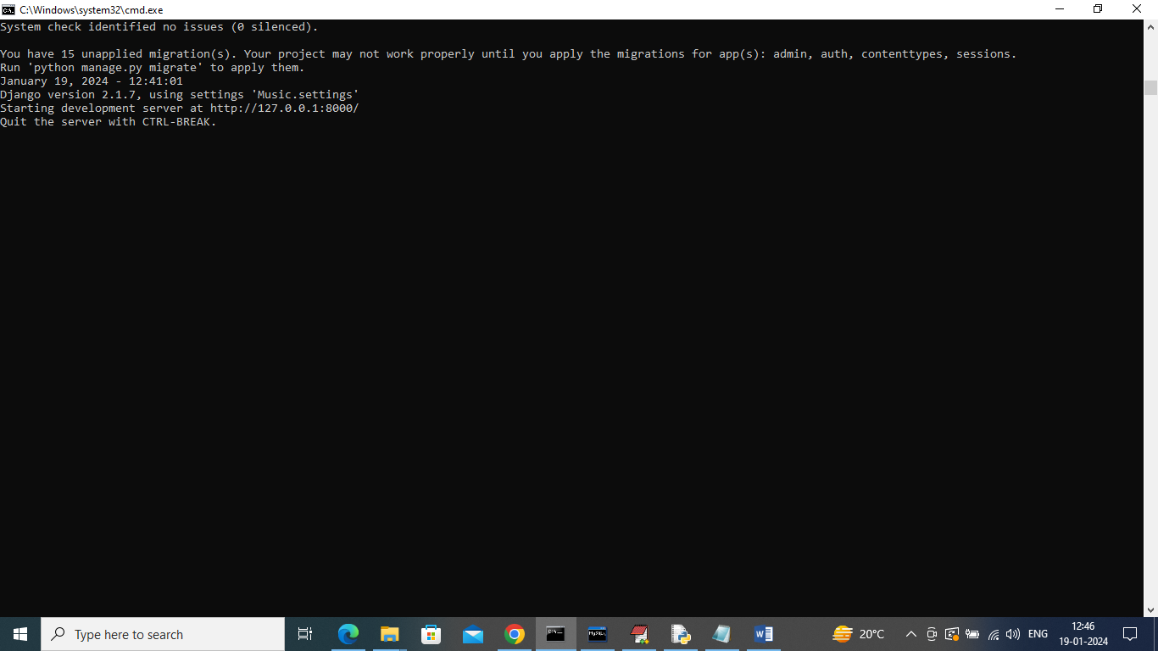

In above screen python server started and now open browser and enter URL as <http://127.0.0.1:8000/index.html> and then press enter key to get below page

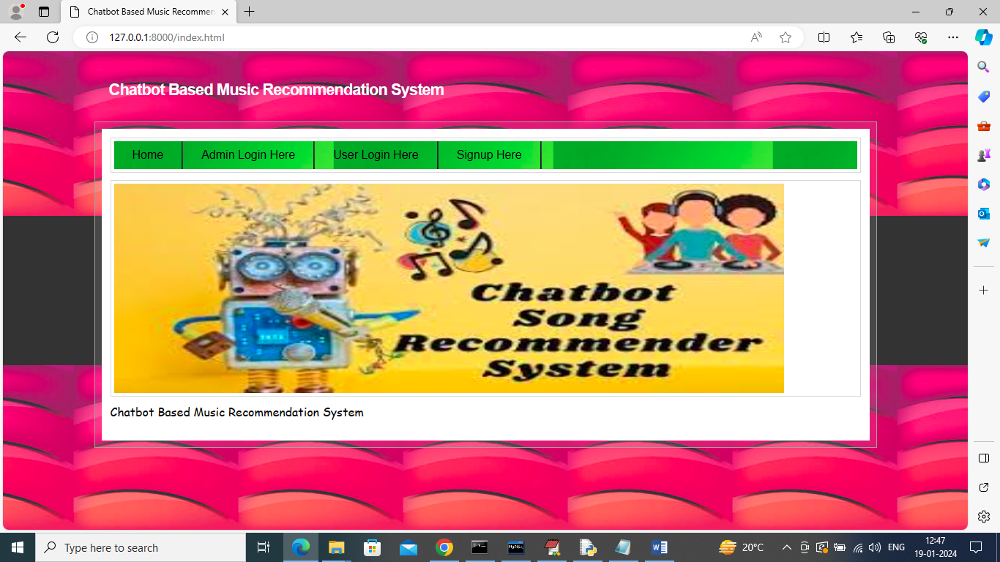

In above screen click on ‘Admin Login Here’ link to get below long page

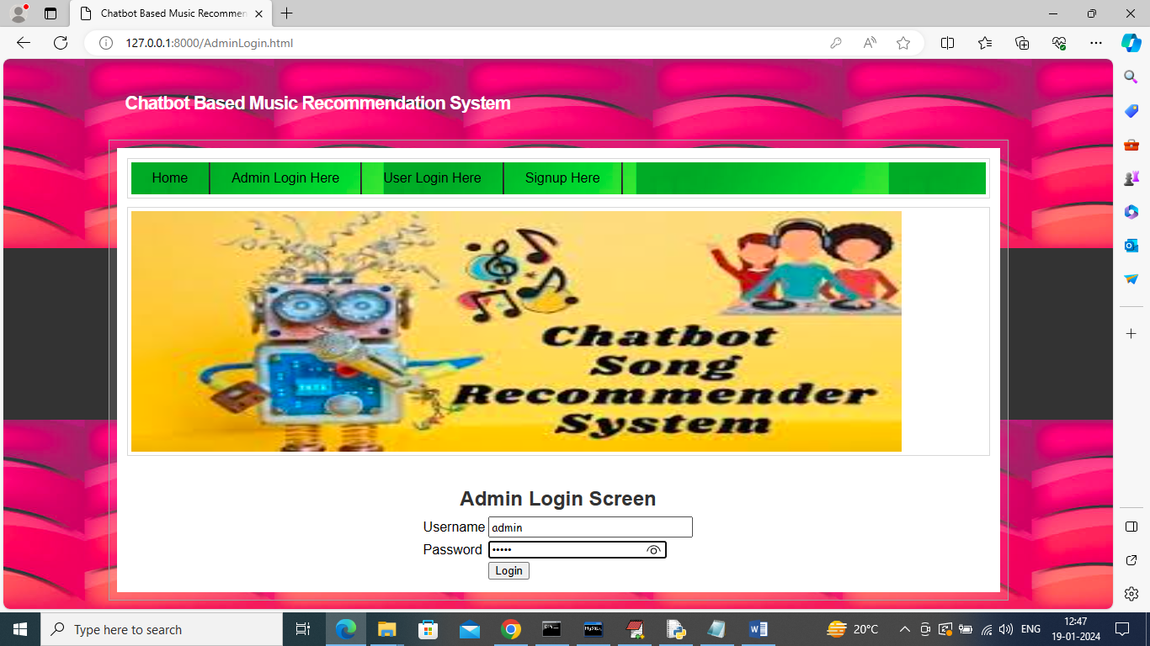

In above screen admin is login and after login will get below page

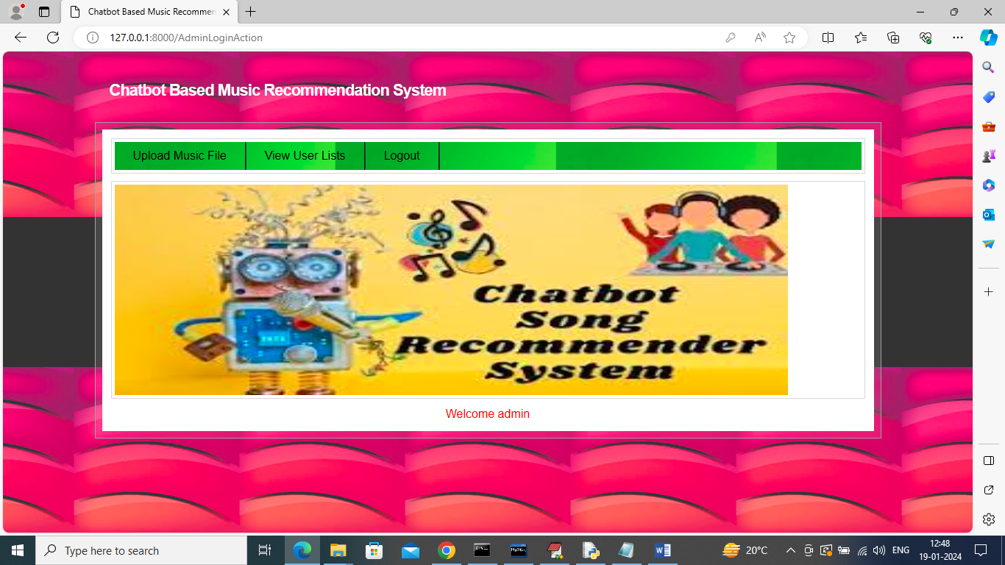

In above screen click on ‘Upload Music File’ link to get below page

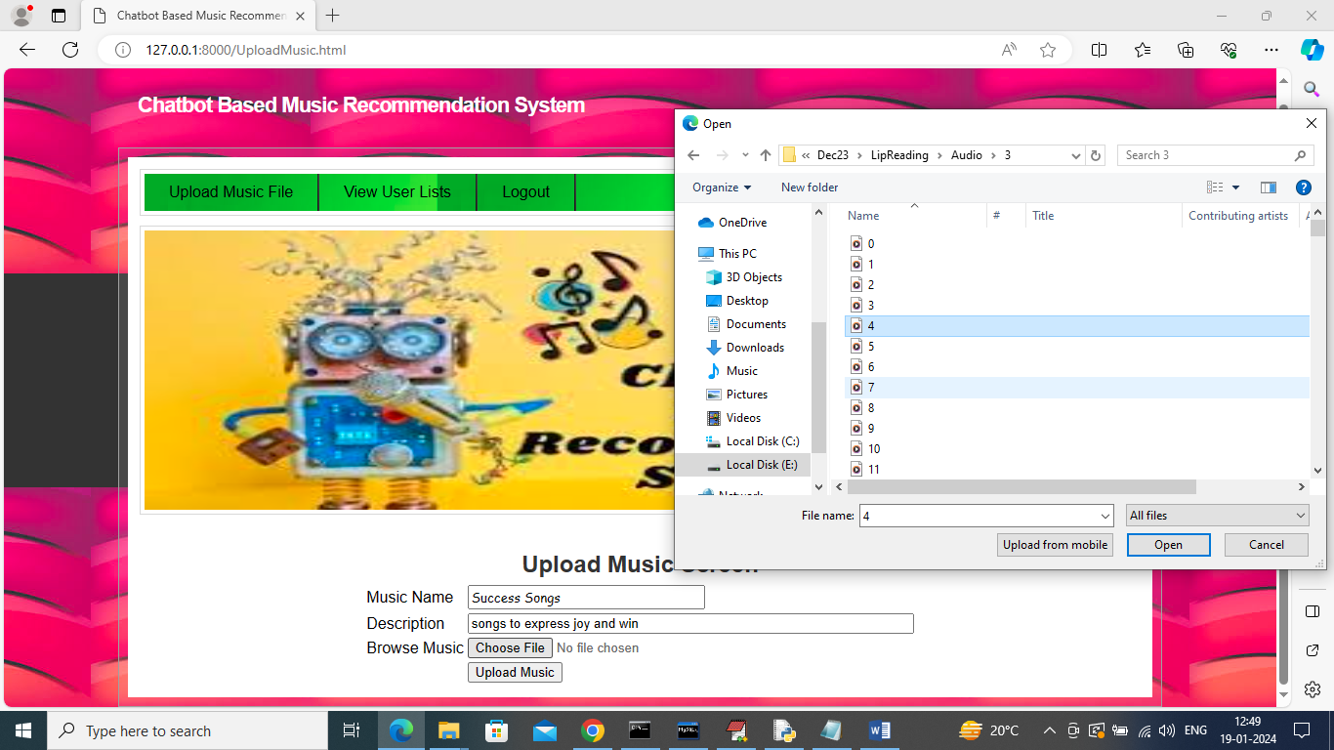

In above screen admin is uploading songs by entering description and then upload songs file and then press button to upload song

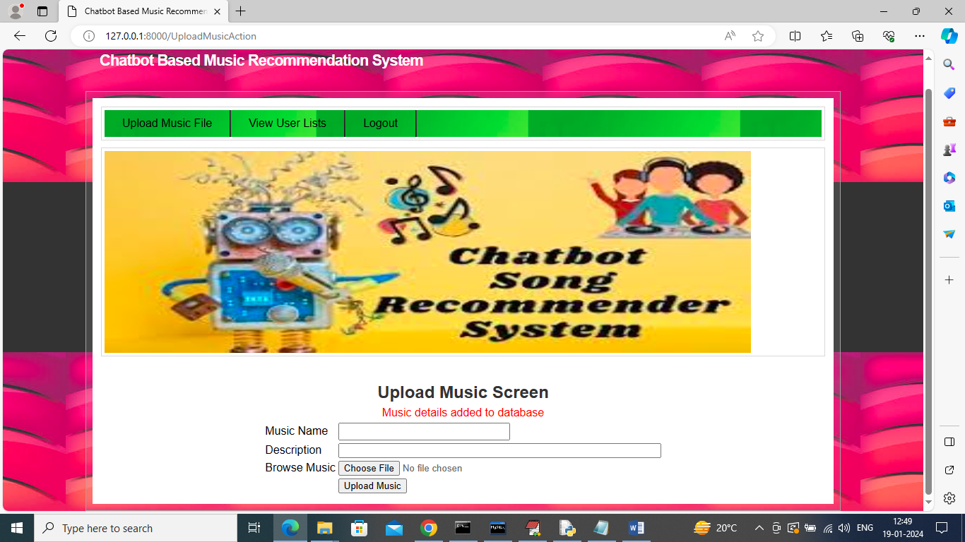

In above screen song is uploaded and similarly you can upload any number of songs and now click on ‘View User List’ link to get below registered user details

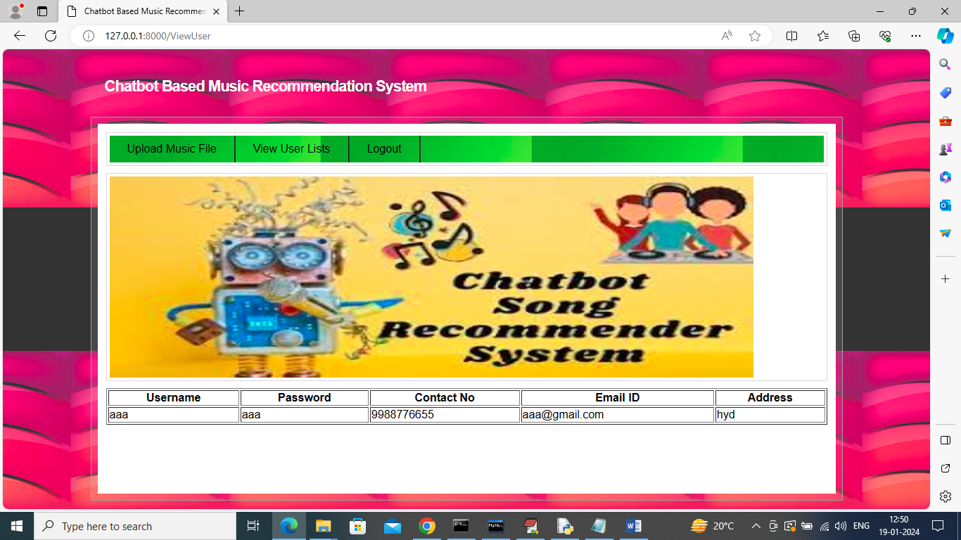

In above screen admin can view list of registered users and now logout and register new user

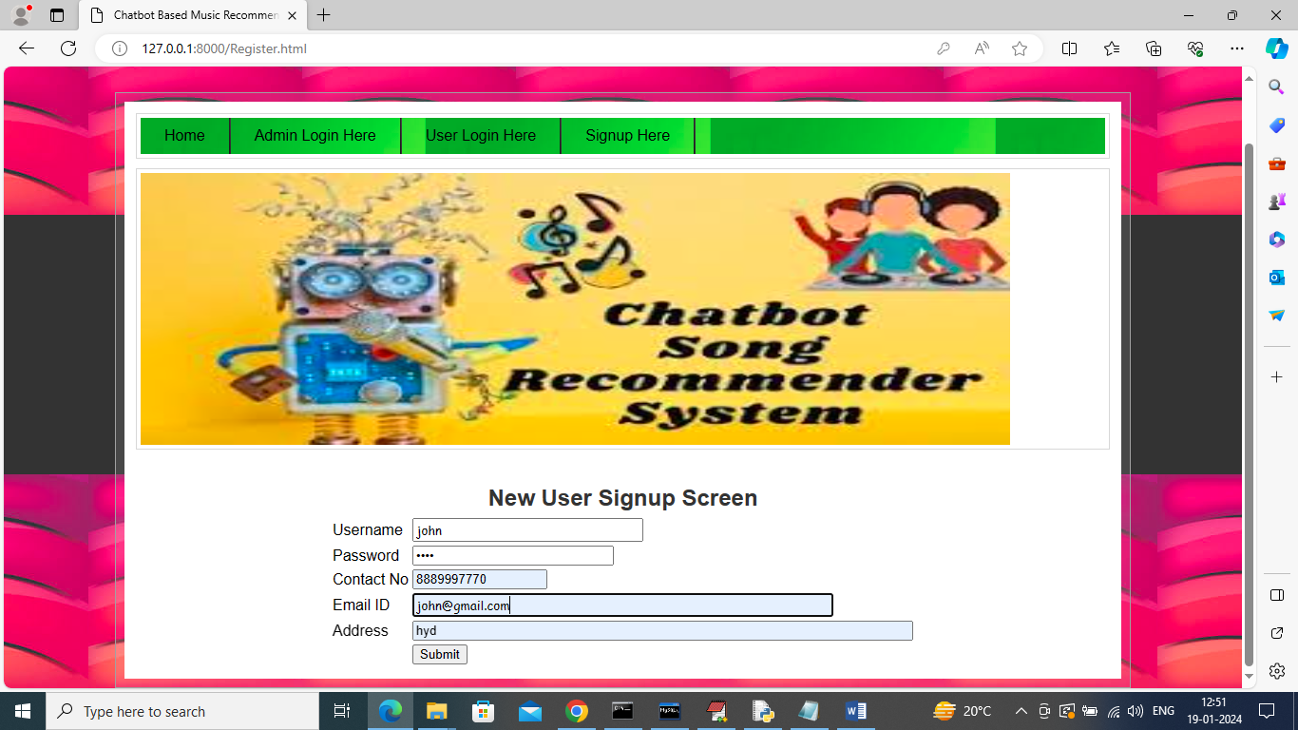

In above screen user is entering sign up details and then press button to get below page

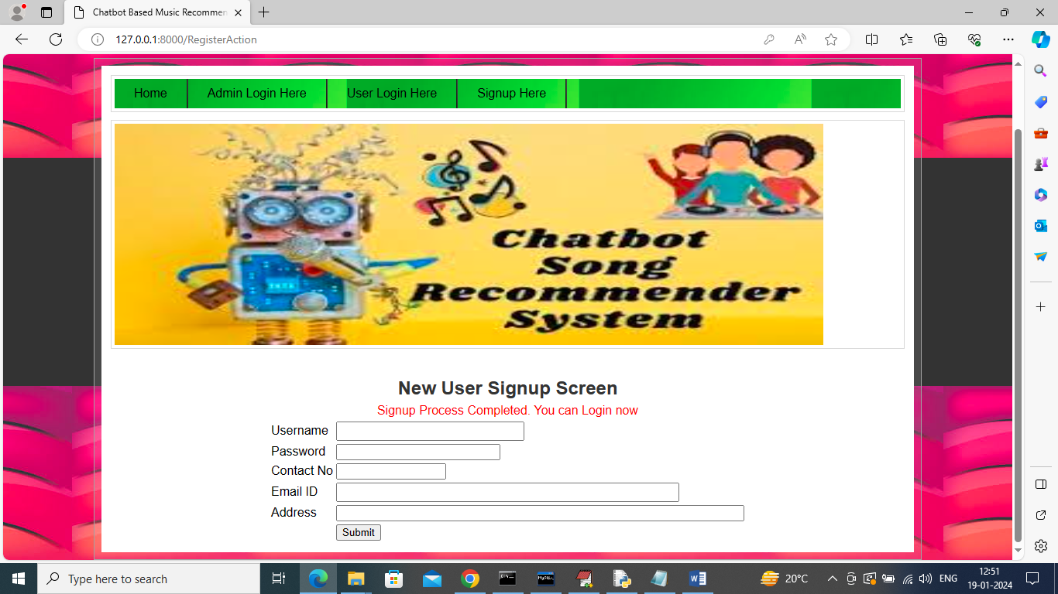

In above screen user signup completed and now click on ‘User Login’ link to get below page

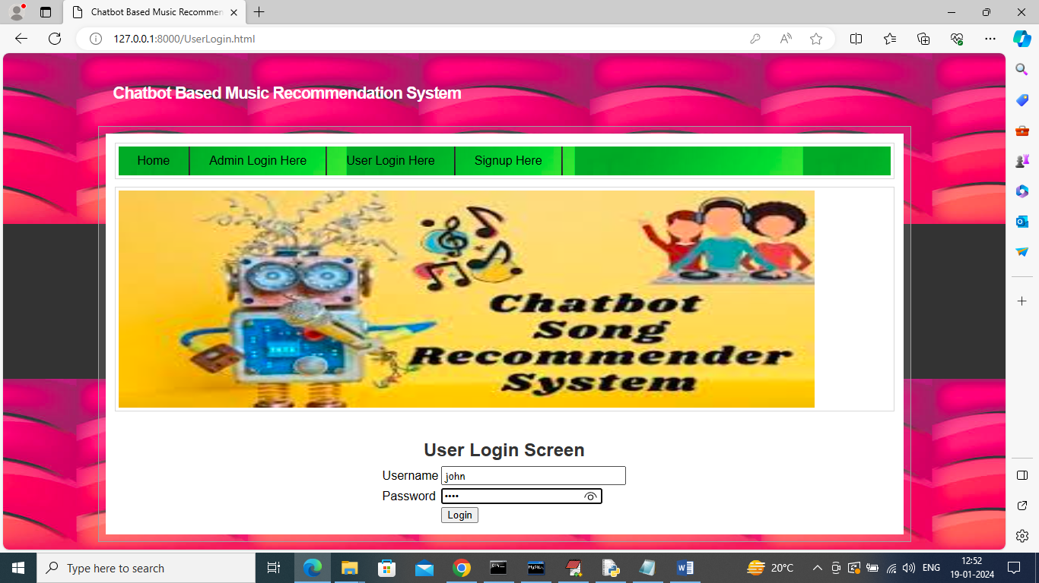

In above screen user is login and after login will get below page

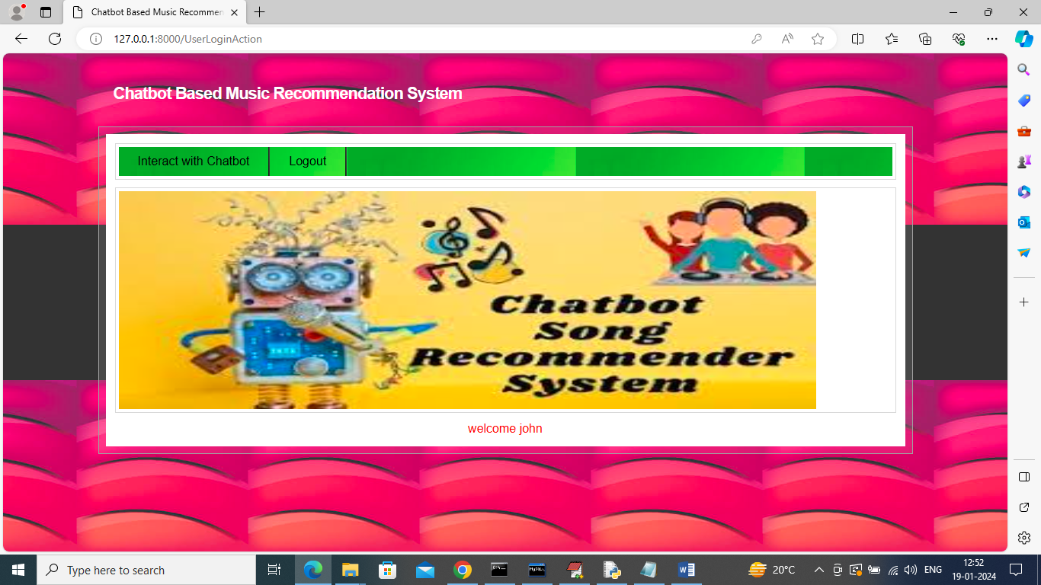

In above screen click on ‘Interact with Chatbot’ link to get below page

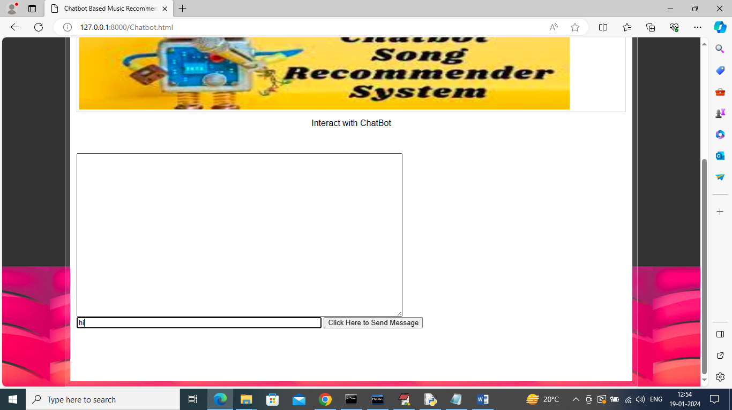

In above screen I am sending ‘hi’ to Chatbot and then press button to get below page

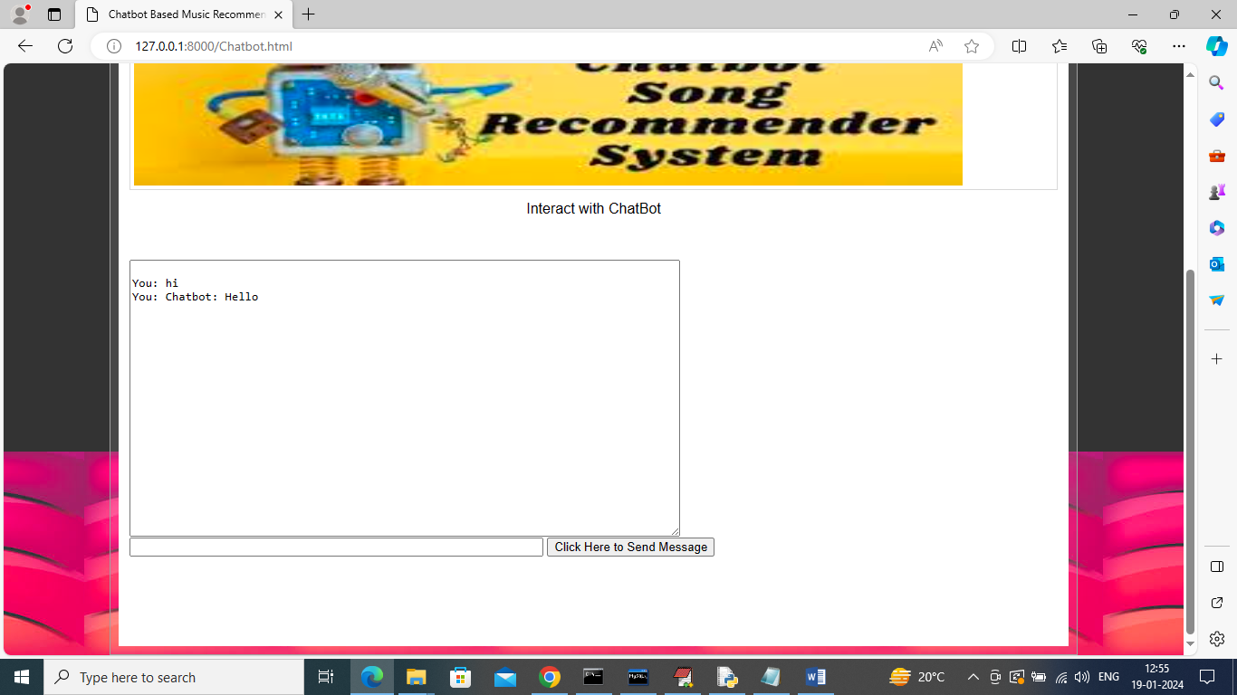

In above screen Chatbot replied with ‘hello’

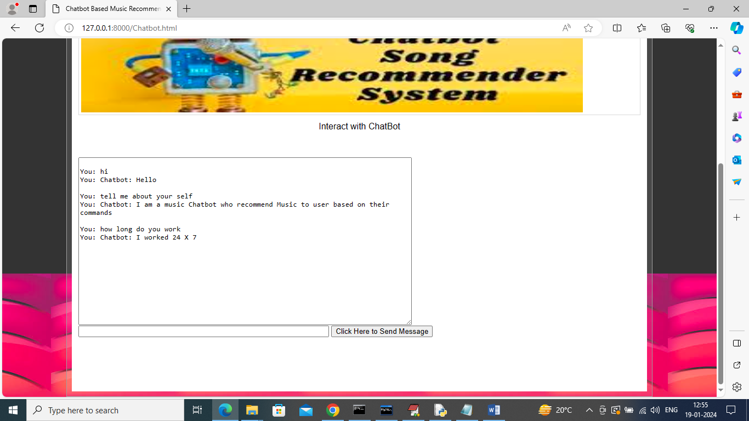

I asked some more questions and Chatbot replied and now I will ask about songs

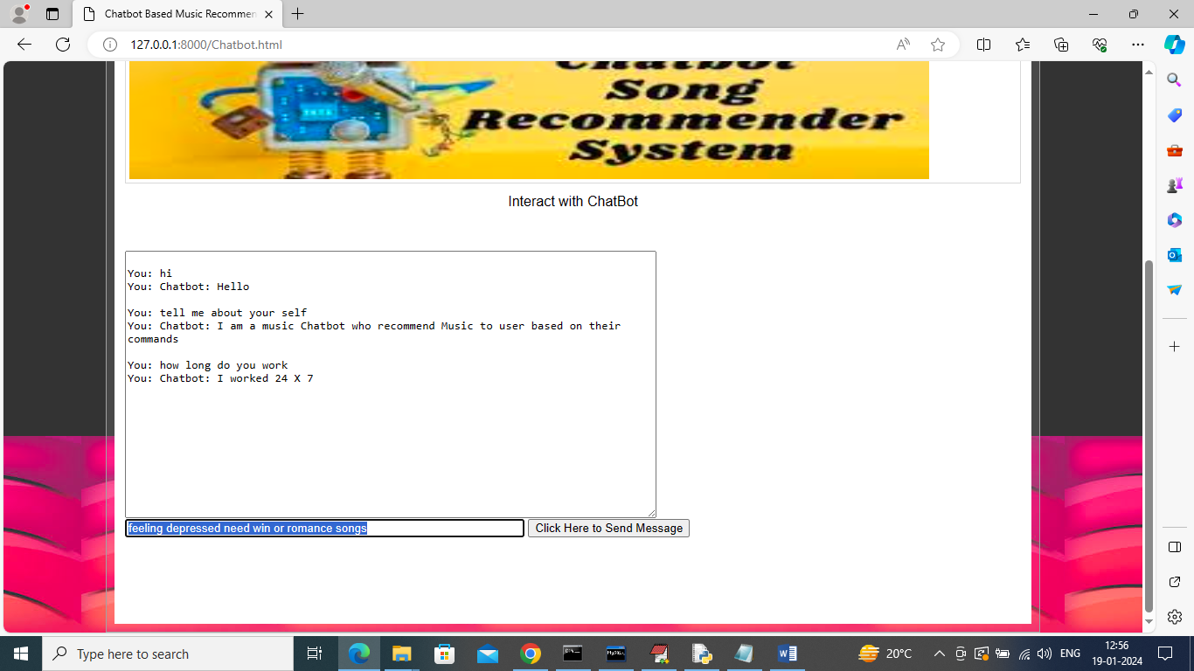

In above screen in blue colour text asking about some songs and then press button to get below page

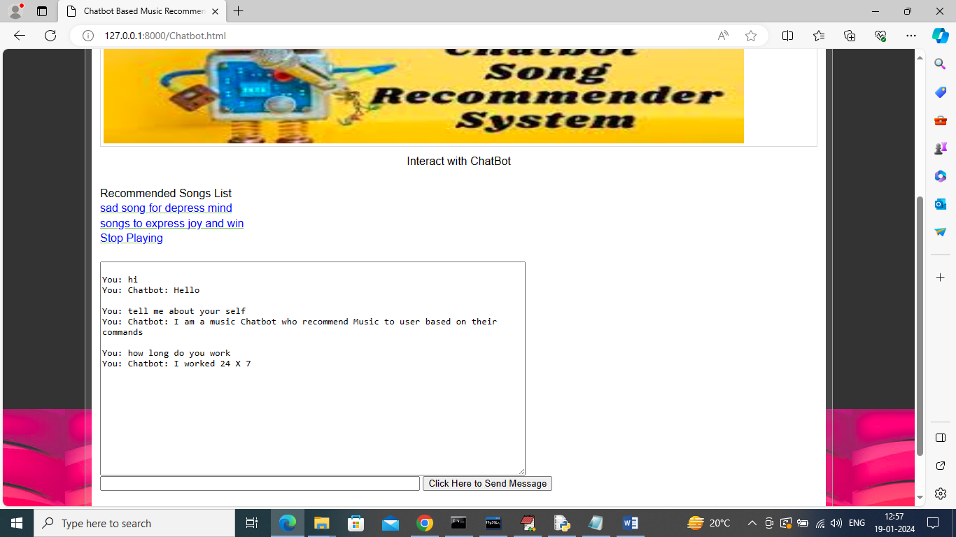

In above screen we got some recommended songs list in blue colour text and you can click those links to play songs and can click on ‘Stop Playing’ to stop songs